TITLE OF PROJECT REPORT

<Font Size 18><1.5 line spacing><Font Style Times New Roman – Bold>

A PROJECT REPORT

<Font Size 14><Font Style Times New Roman – Bold>

Submitted by

<Font Size 14><Italic><Font Style Times New Roman – Bold>

NAME OF THE CANDIDATE(S)

<Font Size 16><Font Style Times New Roman – Bold>

in partial fulfillment for the award of the degree of

<Font Size 14><1.5 line spacing><Italic><Font Style Times New Roman – Bold>

NAME OF THE DEGREE

<Font Size 16><Font Style Times New Roman – Bold>

IN

BRANCH OF STUDY

<Font Size 14><Font Style Times New Roman>


Chandigarh University

MONTH & YEAR

<Font Size 14>

TITLE OF PROJECT REPORT

A PROJECT REPORT

Submittedby

John Doe (UID) Jane Doe (UID)

in partial fulfillment for the award of the degree of

BACHELOR OF ENGINEERING

IN

ELECTRONICSENGINEERING


Chandigarh University

MAY 2023

BONAFIDE CERTIFICATE

<Font Style Times New Roman – size -16>

<Font Style Times New Roman – size -14>
Certified that this project report “………. TITLE OF THE PROJECT…………….” is the bonafide work of “…………..NAME OF THE CANDIDATE(S).…………” who carried out the project work under my/our supervision.

<<Signature of the HoD>>

SIGNATURE

<<Name of the Head of the Department>>

HEAD OF THE DEPARTMENT

<<Department>>

<<Signature of the Supervisor>>

SIGNATURE

<<Name>>

SUPERVISOR

<<Academic Designation>>

<<Department>>

Submitted for the project viva-voce examination held on

INTERNAL EXAMINER EXTERNAL EXAMINER

TABLE OF CONTENTS
List of Figures i
List of Tables ii
Abstract iii
Graphical Abstract iv
Abbreviations v
Symbols vi
Chapter 1 4

1.1 ................................................................................................................................ 5

1.2 ..................................................................................................................................

1.2.1 ..........................................................................................................................

1.3 ..................................................................................................................................

1.3.1 ..........................................................................................................................

1.3.2 ..........................................................................................................................

Chapter 2. ....................................................................................................................

2.1 ..................................................................................................................................

..................................................................................................................................

2.2 ..................................................................................................................................

..................................................................................................................................

Chapter 3. ....................................................................................................................

Chapter 4. ………………………….………………………………………...

Chapter 5. ……………………………………………………………………

References (If Any) ......................................................................................................

List of Figures

Figure 3.1 ………………………………………………………………………………….

Figure 3.2 ………………………………………………………………………………….

Figure 4.1 …………………………………………………………………………….……

List of Tables

Table 3.1 ………………………………………………………………………………….

Table 3.2 ………………………………………………………………………………….

Table 4.1 …………………………………………………………………………….……

ABBREVIATIONS

- GPS: Global Positioning System
- IMU: Inertial Measurement Unit
- INS: Inertial Navigation System
- INFOSEC: Information Security
- IoT: Internet of Things
- IIoT: Industrial Internet of Things
- IP: Internet Protocol
- IR: Infrared
- IS: Information Security / Islamic State
- ISO: International Organization Standardization
- ISS: International Space Station
- FEWS NET: Famine Early Warning System Network
- GIS: Geographic Information System
- GPM: Global Precipitation Measurement mission
- A2 / AD: Anti-access / Area Denial
- DOS: Denial of Service cyber attack
- DPRK: Democratic People’s Republic of Korea
- FAA: Federal Aviation Administration
- DSA: Detect, sense and avoid / Dynamic Sense-and-Act
- DSS: Decision Support System
- DSSS: Direct sequence spread spectrum
- GLOW: Gross lift-off weight for a missile / rocket
- GNSS: Global Navigation Satellite System
- GLONASS: Global Satellite Navigational System
- GPSSPOOF: Hack of GPS system affecting UAS commands
- GPWS: Ground proximity warning system
- SPS: Standard position service (GPS)
- SSA: Static Sense-and-Act

ABSTRACT

The use of the Human Security Assistance System with GPS Location Tracking and Messaging System can enhance several aspects of human security. Along with helping to avoid crime and terrorism, the suggested methodology can also be used in client management. Practitioners can learn more about GPS technology and how it might impact an agency's supervision program by using this system. It is possible to use the system to alert those around and ensure women's safety in an emergency. With the ability to track users' whereabouts and send emergency contacts SMS notifications, the system is a helpful instrument for ensuring human security. The software and the Nodemcu ESP8266 microcontroller of the device. Software for the Arduino IDE is used in the system in conjunction with the Nodemcu ESP8266 microcontroller. Furthermore, a resistive sensor that is a component of the system is managed by an Internet of Things-based wearable human protection system. The proposed model can ensure the protection of individuals, especially women, children, and the old. The technology can be used to determine specific container locations, contents, and whether or not they have been opened. Large-scale population movements are tracked using the Global Positioning System (GPS) technology during humanitarian disasters. The technology can be used to find the user in addition to notifying hospitals and fire stations in the case of an accident or fire. The proposed model may be a helpful tool for ensuring the security of people as well as individual safety.

GRAPHICAL ABSTRACT

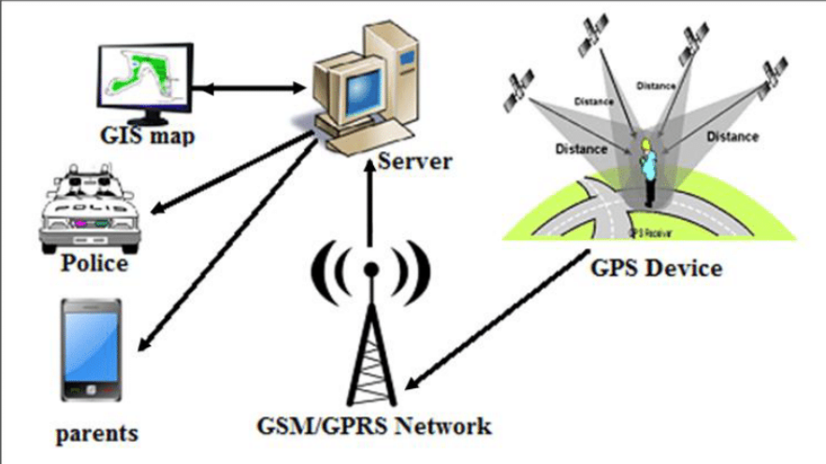

CHAPTER 1: INTRODUCTION

1.1 Introduction:
An approach for human security monitoring that can be utilized to guarantee people's protection is the Human Security Assistance System with GPS Location Tracking and Messaging System. With its people-centered and multidisciplinary approach to security, the paradigm of human security challenges the conventional idea of national security in order to grasp global vulnerabilities.
Various aspects of human security can be improved and client management can be implemented with the help of the suggested model. Through the use of the system, practitioners can have a deeper comprehension of GPS technology and how it may affect the supervisory program of an organization. When an emergency arises, the system can be utilized to notify those in the vicinity and protect the safety of women.

It is an efficient instrument for maintaining human security because the system may be used to
track people's whereabouts and can notify emergency contacts via SMS. Individual safety, particularly that of women, children, and the elderly, can be guaranteed by utilizing the suggested approach. In addition to sending notifications to fire stations and hospitals in the event of an accident or fire warning, the system can be used to determine where the user is. Individual safety and human security can both be effectively ensured with the help of the suggested model.

1.2 Problem Identification
Current considerations that are pertinent to a human security system are as follows:
• Privacy: The use of GPS technology to track people creates concerns over the right to privacy. The amount of information that may be gleaned from a person's movements and the potential applications of that knowledge are sources of concern. Laws pertaining to geolocation privacy forbid the use of this technology for regular surveillance purposes.

• Ethical concerns: There are significant ethical questions raised by the capability to track an individual's travels via GPS. Even when permission is originally granted, ongoing surveillance of a subject's activities by a researcher carries the risk of invasion of privacy and psychological fallout from the sensation of being "watched."

• Technological developments: Preventing crime and terrorism in the twenty-first century will depend more and more on technology. It is possible to stop crime and terrorism by using GPS technology. But technological progress might sometimes result in privacy violations.

• Humanitarian emergencies: In times of humanitarian crisis, GPS technology is utilized to track large-scale population migrations. In order to monitor large-scale population movements during humanitarian crises, United Nations agencies, particularly UNHCR, use space technologies like satellite imagery, Geographic Information Systems (GIS), and the Global Navigation Satellite System (GNSS).

• New location-based technologies: In an attempt to learn more about the current status of the GPS industry and possible future trends, a survey was sent to GPS community monitoring businesses. The research examines the current status of GPS devices for community monitoring as well as the development of new location-based technologies.

These modern concerns can be taken into account while developing a human security system project that uses GPS location to protect people while resolving ethical and privacy considerations.

1.3 Task Identification:
The following activities must be recognized and completed in order to create a human security system that uses GPS location:

Determine the essential elements of human security: The project team must ascertain the essential elements of human security, which encompass safeguarding against long-term dangers including malnourishment, illness, and persecution, as well as defense against abrupt and harmful disturbances to everyday routines. This will make it easier to make sure that the system is built to handle the most serious risks to the security of people.

The project team must create a location-based personal task reminder for mobile users in order to guarantee that the system is efficient and easy to use. This will guarantee that people are able to recall crucial assignments and appointments.
The project team must examine GPS data for psychological research in order to gain a deeper understanding of how people utilize GPS technology and how it affects their sense of security. This will make it easier to guarantee that the system is made to accommodate different needs and effectively improve human security.

Determine possible risks to human security: The project team must determine possible risks to human security, such as armed conflicts, health problems, law and order problems, state power, the economy, and the environment. This will make it easier to make sure that the system is built to handle the most serious risks to the security of people.

The project team must create a system that is both flexible and adaptive so that it may be updated and changed in response to the emergence of new technologies. That way, the system's ability to improve human security over time will be strengthened.

The project team can create a user-friendly, efficient, and flexible human security system that can be adjusted to new needs and technological advancements by recognizing and tackling these objectives. The system will utilize GPS location.

1.4 Timeline
The fictitious chronology listed below can be taken into consideration while creating a human security system that uses GPS location:

Phase 1: Identify the essential elements of security for people and any risks to those elements.
- Provide a mobile user-friendly personal task reminder that is location-based.
* To learn more about how people utilize GPS technology and how it affects their sense of security, do psychological research using GPS data analysis.

Phase 2: Provide an adaptive and flexible system that can be updated and changed in response to the emergence of new technologies.
- To test the system and get user feedback, do a pilot study.
- Discuss privacy issues and moral issues surrounding the usage of GPS technology.

In phase three, the system is refined in response to input from the pilot research.
- Carry out a more extensive investigation to see whether the system is beneficial in improving human security.
- Create a plan to expand the system's reach to a larger audience.

Phase Four: Establish the system in an actual environment.
- Track system performance and make required modifications in response to user input.
- Keep discussing ethical issues and privacy concerns pertaining to GPS technology use.

Phase 5: Assess how the system will affect human security in the long run.
Formulate a strategy for long-term system maintenance.
- Promote the use of GPS technology to improve human security by disseminating research findings and best practices to other organizations and stakeholders.

The project team can create a user-friendly, efficient, and flexible human security system that can be adjusted to new needs and technological advancements by adhering to this fictitious timeframe.

CHAPTER 2: LITERATURE SURVEY

2.1 Existing Work

Timeline of the Reported Issue as Examined Globally: 2003 saw the release of "Human Security Now," a report by the Commission on Human Security that emphasized the need to protect and uphold people's fundamental liberties and advocated for a new strategy for development that would enable people to live without hunger, fear, anxiety, or humiliation.

2012: The Secretary-General reports to the General Assembly on the progress made in the field of human security since the World Summit in 2005. The paper highlights major human security projects carried out by countries, intergovernmental organizations at the regional and sub-regional levels, and UN agencies and authorities.

2019: A paper is released discussing the moral issues surrounding the use of GPS-based mobility tracking in medical studies. The study emphasizes the significance of discussing ethical
risks associated with privacy and data security breaches.

2022: The "2022 Special Report on Human Security," released by the United Nations Development Programme, looks at a number of risks that have changed and become more noticeable recently, including those posed by digital technology. The study reveals that after years of successful upward progress, people's perception of safety and security is at an all-time low in practically every nation, even the wealthiest nations.

General Assembly convenes in 2023 to discuss the Secretary-General's report, "Follow-up to General Assembly Resolution 64/291 on Human Security." The final section of the study includes a series of suggestions meant to encourage the integration of human security into UN operations and the use of it as an overarching framework in the post-2015 Development Agenda.

2023: Space and Water: Towards Sustainable Development and Human Security, an international conference, has a keynote speech. The use of GPS technology to find specific container locations, contents, and whether or not they have been opened is discussed in the lecture. In addition, the presentation emphasizes how satellite imagery, Geographic Information Systems (GIS), and the Global Navigation Satellite System (GNSS) are used to track large-scale population migrations in times of humanitarian crisis.

The need to address concerns about GPS use and human security is becoming more pressing, as evidenced by an international investigation into the subject. The results of these reports and investigations can help with the creation of a human security system that uses GPS location is efficient, easy to use, and takes privacy, ethics, and technology issues into account.

2.2 Problem:

- The usage of GPS technology raises privacy concerns.
- The usage of GPS technology and its ethical implications.
- Potential privacy breaches brought on by technological improvements.
- Difficulties in guaranteeing that GPS technology be applied with efficacy and efficiency in humanitarian crises.
- New technologies that are location-based.

2.3 Goals:
- Building an adaptive and flexible system that can be updated and changed in response to the emergence of new technologies.
- Addressing ethical and privacy issues around the use of GPS technology.
- Determining possible dangers to the safety of people.

2.4 Objectives:
- Creating a tailored task reminder for mobile users based on location.
- To learn more about how people utilize GPS technology and how it affects their sense of security, psychological researchers are analyzing GPS data.
- To test the technology and get user input, a pilot study will be carried out.
- Making system improvements in response to input from the pilot study.
- Carrying out a more extensive analysis to determine how well the system improves human security.
- Creating a strategy for expanding the system's reach to include more users.
- Watching the system and modifying it as needed in response to user input.
- Assessing how the system will affect human security in the long run.
- Formulating a strategy to maintain the system in the long run.
- Encouraging the use of GPS technology to improve human security by disseminating research results and best practices to other organizations and stakeholders.

promoting the application of GPS technology to enhance human security by sharing best practices and research findings with other organizations and stakeholders.

Chapter 3: Design flow/Process

3.1 Concept Generation:
A Human Security Assistance System with GPS Location Tracking and Messaging System can be a valuable tool for enhancing personal safety and providing assistance in times of need. Here are some of the key reasons why such a system can be beneficial:
- Enhanced Personal Safety: The system can act as a deterrent against crime and harassment, as potential perpetrators may be hesitant to target individuals knowing that their location can be quickly tracked and shared with authorities.

- Real-Time Location Tracking: In emergency situations, the system can provide real-time location information to emergency responders, enabling them to reach the scene quickly and effectively.

- Two-Way Communication: The messaging feature allows for two-way communication between the user and designated contacts, enabling them to provide assistance and support during times of crisis.

- Peace of Mind for Individuals and Families: The system can provide peace of mind for individuals and families, knowing that there is a mechanism in place to help them in case of an emergency.

- Empowerment for Vulnerable Individuals: The system can empower vulnerable individuals, such as women, children, and the elderly, by giving them a means to seek help and protect themselves.

- Data-Driven Insights for Safety Improvement: The system can generate valuable data on safety patterns and potential risks, which can be used to inform preventive measures and safety interventions.

- Integration with Existing Emergency Services: The system can be integrated with existing emergency services, enhancing their ability to respond to emergencies and provide assistance to individuals in need.

- Potential for Wider Applications: The underlying technology can be adapted for a variety of applications beyond personal safety, such as monitoring the whereabouts of individuals with special needs or tracking assets in a corporate setting.

3.2 Evaluation & Selection of Specifications/Features:

Evaluating and selecting the appropriate specifications and features for a Human Security Assistance System with GPS Location Tracking and Messaging System (HSAS) is crucial for ensuring its effectiveness in safeguarding individuals and providing timely assistance in emergency situations. Here's a comprehensive guide to evaluating and selecting the key components of an HSAS:

GPS Location Tracking Accuracy:
      - High-Precision Location Data: This means that very precise location data should be provided by the GPS module. It should be highly accurate in determining the location of the user, ideally within a few meters or even less. For applications like navigation, mapping, and other kinds of scientific study where exact position information is needed, this degree of precision is essential.

      - Coverage in Various Environments: In a variety of settings, the GPS device ought to be able to sustain a dependable signal and deliver precise location information. This includes rural locations with fewer nearby cell towers or reference points, metropolitan places with towering structures that could block satellite signals, and even indoor settings where there might not be a direct line of sight to satellites. In order to make the system functional in a variety of settings, it is imperative that good coverage be ensured across these varied environments.

      - Real-time or Near Real-time Updates: This means that timely location updates should be provided by the GPS system. It ought to be fast in monitoring and reporting shifts in the user's location. For instance, having current location data about a user is essential in applications such as fleet management and live navigation. Because the updates are almost real-time, there might be a small lag (a few seconds to several minutes), but the data is still up to date.

      - Power Efficiency: As little power as feasible should be used by the GPS module without sacrificing precise tracking. This is crucial since using GPS can seriously deplete a device's battery. To ensure that a gadget can run for lengthy periods of time without continually needing to be recharged, energy efficiency is essential. This is crucial in situations where the gadget must run off the grid or in distant areas for extended periods of time.

In conclusion, applications requiring precise and current location data while also preserving battery life will find great value in a GPS system with high-precision position data, dependable coverage in a variety of situations, real-time or almost real-time updates, and good power efficiency. The efficacy of the system in many settings is guaranteed by the amalgamation of these qualities.

Messaging System
A messaging system is a communication platform that allows users to exchange messages with one another. Let's explore the key features mentioned:

      - Two-way Communication: Two-way communication means that the messaging system enables both sending and receiving messages. Users can send messages to their designated contacts, and they can also receive messages from those contacts. This bi-directional communication is fundamental for effective and interactive conversations.

      - Message Delivery: Reliable message delivery is crucial for ensuring that messages reach their intended recipients. In areas with limited cellular coverage or unstable internet connections, the messaging system should be designed to handle message delivery challenges, such as by queuing and retrying messages until they can be successfully delivered. This is particularly important in remote or disaster-prone regions where network connectivity can be unpredictable.

      - Emergency Alerts: Providing a mechanism for sending emergency alerts is a critical feature in a messaging system, especially for personal safety and security. Users should have the ability to send distress signals or emergency alerts to their designated contacts, indicating that urgent assistance is needed. This feature can be a lifeline in situations where immediate help is required, such as medical emergencies or personal safety concerns.

      - Message Encryption: Message encryption is essential for maintaining the confidentiality and privacy of messages. When messages are encrypted, their content is scrambled and can only be decrypted by the intended recipient, ensuring that unauthorized parties cannot intercept or read the messages. This is crucial for protecting sensitive information and personal privacy, particularly in messaging systems used for business communication, healthcare, or other contexts where data security is paramount.

In addition to the mentioned features, a messaging system may also include other functionalities such as multimedia message support (including images and videos), message archiving, group chats, read receipts, and integration with other services or applications. The design and features of a messaging system can vary depending on its intended use, whether it's for personal communication, business communication, or specialized purposes like healthcare or emergency response.

Additional Specifications

1. Device Form Factor: The device is lightweight, portable, and tiny, making it effortless to use, store, and carry around without causing any strain. In situations where the user must always carry the device, it is extremely crucial. This could include medical supplies, personal safety gadgets, or instruments that emergency responders and other professionals utilize on the job. In circumstances where the user wishes to keep the gadget quiet, a discrete design is also crucial.

2. Battery Life: Devices that must run constantly or for lengthy periods of time without periodic recharging require long battery lives. This is particularly crucial in scenarios like outdoor activities, isolated places, or emergency circumstances where access to power sources may be restricted. When needed, a long-lasting battery guarantees that the gadget will continue to work.

3. Durability: To guarantee that the gadget can endure daily abuse and perform dependably in a range of environmental circumstances, durability is essential. Devices could be subjected to physical shocks, dust, dampness, and extremely high or low temperatures, among other things. For longevity and dependability, durability is crucial, regardless of whether the instrument is utilized in an industrial context or as a consumer electronic gadget.

4. Ease of Use: Device accessibility for a diverse user base depends on their ease of use. Even in urgent or stressful conditions, the device should be easy to activate and operate and have a straightforward interface. A product with an intuitive design is easier for consumers to understand and operate, reducing the learning curve.

5. Cost-Effectiveness: In order to make the technology available to a larger audience, cost-effectiveness is crucial. In addition to meeting the other standards, it is imperative that you do so in a way that maintains the device's affordability. This may entail employing economical materials, producing goods efficiently, and setting competitive prices.

While creating a gadget for professional use, personal use, or specialized applications, these factors are essential to take into account. The device's intended user base and particular use case will determine how these elements are balanced.

Selection Process

- Identify User Needs: Understanding the unique demands and expectations of the users is the cornerstone of every successful HSAS development. In order to learn more about users' preferences, safety concerns, and intended system usage, research, questionnaires, and interviews must be conducted. Ensuring the system is developed with end users in mind is ensured by this phase.

- Evaluate Available Solutions: Prior to building an HSAS, it is essential to investigate and assess the market's current solutions. This aids in comprehending the features and specifications that are now offered and how they stack up against the determined needs of the consumer. This stage can assist in finding areas where the current solutions have weaknesses or room for improvement.

- Consider Integration: It is imperative that the HSAS is integrated with the current emergency services and security infrastructure in order to facilitate seamless communication and data exchange with external systems. Compatibility with other home automation or security systems as well as local emergency services like the police and fire departments may be required for this. A seamless integration increases the system's overall efficacy.

- Conduct User Testing: Sessions for user testing and feedback are essential for improving the HSAS. In order to get feedback on the system's performance, usability, and suitability for users' needs, this phase entails putting the system in their hands. User feedback can direct improvements and highlight problems that may not have been obvious during development.

- Continuous Evaluation: Creating and maintaining an HSAS needs to be a continuous procedure. It is essential to examine and assess the system's performance on a regular basis. This entails determining what needs to be improved upon and keeping up with changing user requirements and technology developments. The HSAS needs to evolve in order to stay current and useful since both technology and user requirements can change over time.

3.3 Design Constraints– Regulations
In order to guarantee compliance, privacy protection, and user safety, a Human Security Assistance System (HSAS) with GPS position monitoring and messaging system must be carefully designed and implemented while taking into account a number of legislative and design restrictions. Here are some important things to consider about:

3.3.1 Data Privacy and Security

      - Data Collection and Storage: Adhering to data privacy regulations is essential to ensure that the collection, storage, and use of personal data, such as location information and user messages, are done in a lawful and ethical manner. Regulations like GDPR (General Data Protection Regulation) and CCPA (California Consumer Privacy Act) provide guidelines and requirements for handling user data. Compliance with these regulations is important to protect user privacy and avoid legal consequences.

      - Consent and Transparency: Obtaining explicit informed consent from users is a fundamental principle of data privacy. Users should be aware of what data is being collected, how it will be used, and with whom it will be shared. This transparency is crucial for building trust with users. Clearly informing users about data collection practices ensures that they have the choice to opt in or out based on their preferences.

      - Data Security: Data security is a critical aspect of protecting user data from unauthorized access, breaches, and misuse. Implementing robust security measures includes the use of encryption techniques to secure data both in transit and at rest, employing secure access controls to limit who can access the data, and conducting regular data audits to identify and address vulnerabilities. Data breaches can result in significant harm to users and legal consequences for the organization.

      - Data Retention: Establishing clear data retention policies is important for managing user data responsibly. These policies should specify how long user data will be retained and the procedures for data deletion or anonymization once it is no longer necessary for the specified purposes. This ensures that user data is not held indefinitely and is disposed of in a secure and compliant manner.

3.4 Emergency Response Integration

1. Compatibility: In order to guarantee that your system can interact and communicate with recognized emergency services without a hitch, it is imperative that it be compatible with current emergency response systems and procedures. This interoperability makes it possible to communicate vital information to first responders and pertinent authorities, like the nature and location of an emergency. For this integration to go as smoothly as possible, established communication protocols and interfaces must be used.

2. Emergency Alerting: A crucial component of any emergency response system is the implementation of procedures for alerting selected contacts and emergency responders to emergencies. These alerts should provide the exact location as well as pertinent information regarding the emergency's nature, intensity, and any necessary immediate measures. This makes it possible to reply promptly and precisely, giving responders the knowledge, they need to handle the issue successfully.

3. Real-time Updates: Giving emergency responders location updates in real-time or almost real-time is essential for their prompt arrival and response during an incident. Responders can use these updates to keep tabs on the situation as it develops, make well-informed decisions, and modify their plan of action as necessary. In an emergency, precise and timely information can save lives.

These features are essential for creating an effective emergency response system that can help save lives and mitigate the impact of critical incidents. By ensuring compatibility, enabling emergency alerting, and providing real-time updates, you can enhance the overall response and coordination in times of crisis.

3.5 Device Functionality and Reliability

1. Accuracy: Improving personal safety and offering support when needed can be accomplished with the help of a Human Security Assistance System with GPS location tracking and messaging system. These are some of the main advantages that such a system may offer.

2. Coverage: The availability of satellite signals in various situations is referred to as GPS coverage. Maintaining dependable GPS coverage in a variety of situations is crucial.:

- Urban: It can be difficult to stay in contact with GPS satellites in cities filled with tall buildings and barriers. Accurate location data in such situations requires sophisticated GPS technology and signal processing.
- Rural: There can be fewer cell towers or reference points close by in isolated or rural locations. For consumers in these situations, it is crucial that the GPS gadget still obtains precise position data.

- Indoor: Restrictions including a narrower line of sight to satellites can limit the capabilities of indoor GPS. Supplementary technologies such as Bluetooth-based location or Wi-Fi can help sustain tracking capabilities in such situations.

3. Power Efficiency: Energy efficiency is essential to prolong the operational time of the device. GPS modules can consume a significant amount of power, especially when they need to continuously track a user's location. To minimize battery consumption, the device should use energy-efficient components and power management strategies. This is particularly important in scenarios where the device must operate for extended periods, such as outdoor activities or emergency situations.

4. Durability: Device durability ensures that it can withstand the rigors of everyday use and remain functional in various weather conditions. This is crucial, especially for devices used in outdoor activities, sports, or critical situations. Durability involves using materials and designs that can resist physical shocks, moisture, dust, and extreme temperatures, protecting the device's functionality and user safety.

5. Ease of Use: A user-friendly interface is essential for enabling easy activation, operation, and communication, even under stress or in low-light conditions. It's important to design the device's user interface with simplicity and intuitiveness in mind. This can include features like large and easy-to-press buttons, clear displays, and logical menu structures. In critical situations, users should be able to interact with the device without unnecessary complexity or confusion.

In summary, a GPS-enabled device designed with high accuracy, reliable coverage, power efficiency, durability, and ease of use in mind ensures that it can effectively serve its intended purpose, whether that's for navigation, outdoor activities, emergency response, or other applications where location tracking is crucial

.3.6 Regulatory Compliance

- Data Protection Regulations: It is essential to abide by data protection laws, such as the California Consumer Privacy Act (CCPA) in California and the General Data Protection Regulation (GDPR) in Europe. These rules control the collection, storage, use, and sharing of personal data, including location data. Compliance entails getting users' permissions as needed, safeguarding their data, and giving them control over it.

- Privacy Laws: In addition to general data protection rules, there may be privacy restrictions that are particular to the gathering and use of location data. These rules are intended to safeguard user privacy, particularly in situations involving sensitive location data. Ensuring adherence to privacy rules is essential to prevent legal problems stemming from the improper use of location data.

- Emergency Communication Regulations: In order to prevent the HSAS from interfering with or disrupting already-existing emergency communication channels, compliance with legislation governing emergency communication systems is crucial. Strict guidelines and standards are in place for emergency communications in many areas to ensure that crucial information can be communicated promptly and without hindrance.

- Device Certification: To prove that the HSAS gadget satisfies safety regulations and legal criteria for electronic devices, it must obtain the required certifications. These certifications could be in the areas of safety, radio frequency (RF), and electromagnetic compatibility (EMC). Users are reassured by compliance with these standards that the gadget is secure and won't interfere with other devices.

3.7 Economic

Implementing a Human Security Assistance System (HSAS) with GPS location monitoring and messaging can have significant and far-reaching financial benefits. The following is a list of the main financial benefits:
1. Reduced Costs for Emergency Response: An effective HSAS can provide accurate location information and real-time alerts in emergency situations, allowing emergency response services to reach individuals in distress more quickly. This efficiency can lead to cost savings for emergency response agencies by reducing search and rescue efforts and potentially the severity of incidents.

2. Enhanced Productivity and Reduced Absenteeism: A safer home environment can lead to a more secure and stress-free personal life, resulting in a more productive workforce. Reduced accidents or emergencies at home can contribute to lower absenteeism rates, which, in turn, can benefit businesses and organizations by maintaining a consistent workforce.

3. Improved Public Image and Reputation: Implementing an HSAS reflects an organization's commitment to the safety and well-being of its employees and customers. This can enhance an organization's public image, improve its reputation, and help attract and retain top talent.

4. Reduced Liability Costs: By preventing safety incidents, HSAS can help organizations reduce the risk of potential lawsuits and the associated liability costs. This is particularly important for industries where safety and security are paramount.

5. Increased Economic Activity: Safer and more secure environments can stimulate economic activity by attracting businesses, investments, and tourism. When people feel safe, they are more likely to engage in various activities, which can contribute to overall economic growth in a region.

6. Reduced Healthcare Costs: An HSAS can help prevent injuries and provide timely medical assistance in case of emergencies, potentially leading to reduced healthcare costs for both individuals and organizations. Fewer medical expenses and improved health outcomes can result from quick responses to health crises.

7. Peace of Mind and Improved Quality of Life: An HSAS can provide individuals and families with peace of mind, knowing that they have a safety net in place. This can lead to an improved quality of life by reducing stress and anxiety related to safety concerns.

8. Insurance Premium Reductions: Organizations with a proven track record of safety and effective risk management may qualify for lower insurance premiums. Implementing an HSAS that contributes to safety and security can be a factor that insurance providers consider when setting premium rates.

9. Potential Revenue Generation: HSAS technology, particularly if it includes tracking and monitoring capabilities, can be extended to other applications. This can create additional revenue streams, such as offering tracking services for valuable assets or providing monitoring services for other safety and security needs.

10. Reduced Costs for Personal Security Devices: As HSAS technology becomes more widely adopted and integrated into everyday life, it could lead to more cost-effective personal security devices and services. Widespread adoption can drive economies of scale, making advanced safety technology more affordable for consumers.

In summary, an HSAS can bring various benefits, including cost savings, increased safety, and improved quality of life, both for individuals and organizations. The exact benefits realized may vary depending on the specific features and applications of the HSAS and the extent to which it is integrated into daily life and business operations.

3.8 Environmental Issues:

1. Energy Efficiency:
- Designing the system to be energy-efficient means optimizing its operation to consume as little power as possible. This is especially important in mobile devices like smartphones and tablets, where battery life is a critical factor in user satisfaction. Energy-efficient design can involve various strategies, such as:
- Low-Power Components: Using energy-efficient processors, sensors, and displays.
- Power Management: Implementing intelligent power management strategies that reduce power consumption when the device is not in active use.
- Software Optimization: Developing software that minimizes unnecessary background processes and optimizes power-hungry applications.
- Energy-efficient systems are not only beneficial for extending battery life but also contribute to reducing the environmental impact of manufacturing and disposing of batteries.

2. Eco-Friendly Materials:
- Choosing environmentally sustainable materials for device manufacturing is a key component of eco-friendly design. This involves considering the entire lifecycle of the product, from raw material extraction to production, use, and eventual disposal. Key strategies include:
- Recycled Materials: Incorporating materials made from recycled sources.
- Biodegradable Materials: Using materials that are biodegradable or compostable.
- Sustainable Sourcing: Ensuring that materials come from sources that practice responsible and sustainable harvesting or production.

By using eco-friendly materials, the environmental impact of the device's production and eventual disposal can be minimized, reducing waste and resource consumption.

3. Recycling:

- Ensuring that the system's components can be recycled or disposed of in an environmentally responsible manner is crucial for reducing electronic waste and its associated environmental impact. To promote recycling and responsible disposal:
- Modular Design: Designing the device to be easily disassembled, allowing for the separation and recycling of individual components.
- Proper Disposal Guidance: Providing users with information on how to recycle or dispose of the device when it reaches the end of its life.
- Take-Back Programs: Implementing take-back programs that allow users to return old devices for recycling or responsible disposal.

Proper recycling and disposal practices can help reduce electronic waste in landfills and ensure that valuable materials are recovered and reused in the manufacturing of new devices.

By incorporating these sustainability principles into the design and manufacturing of electronic devices, companies can reduce their environmental footprint, promote energy efficiency, and contribute to a more eco-friendly and responsible approach to technology. This is particularly important in the context of a growing awareness of environmental issues and the need for more sustainable practices in the electronics industry.

3.9 Manufacturability:

1. Streamlined Assembly: -
- Lowering Production Expenses: Simplified assembly is the result of designing a product with manufacturing efficiency in mind. A product that is easy to build can be produced more rapidly and with fewer errors. Its efficiency lowers production costs, which might increase the product's overall profitability.

- Lower Labor Costs: Complex assembly techniques may require more time and skilled labor. Simplifying assembly can save labor costs by lowering the need for highly qualified assembly workers.

- Less Defects: Complex assembly procedures are prone to errors, which increases waste and defect rates. Less waste, fewer errors, and less expensive rework might result from a simpler design.

- Faster Time to Market: By employing effective assembly processes, which facilitate quicker production, time to market can be hastened. This is particularly important in industries with high levels of rivalry and rapid technological advancement.

2. Supply Chain Management:

- Stable Component Supply: A strong supply chain is essential to ensuring a steady and reliable flow of the components required for manufacturing. Supply chain disruptions such as shortages or delays may lead to greater costs and production delays.

- Risk Mitigation: Effective supply chain management identifies, evaluates, and reduces supply chain risks. This may entail keeping a safe supply of essential components in store, diversifying your suppliers, and putting backup procedures in place.

- Cost Efficiency: There is a chance to save costs with optimal supply chain management. Optimization of supply chain, reduction of inventory costs, and favorable supplier terms can all contribute to a more cost-effective business.

- Adaptability to Market Changes: A flexible supply chain can change to meet evolving customer needs and take advantage of evolving market conditions. It can quickly scale production up or down as needed, for example, to lessen excess inventory or production shortages.

In summary, good supply chain management and fast assembly play a major role in a product's dependability and cost-effectiveness during manufacture. These strategies not only save production costs but also enable a company to respond faster to challenges, changes in the market, and unplanned disruptions, all of which contribute to the development of more effective and successful products.

3.10 Safety Issues:

- User Safety: Give user safety a priority when designing systems, particularly when there is an emergency.
- Reliability: To reduce the likelihood of system breakdowns at crucial times, design a sturdy and dependable system.
- Security: Put security measures in place to guard user information and make sure bad actors can't undermine the system.

3.11 Professional Issues:

- Professional growth: Give the experts who run and manage the system continual training and growth opportunities
.
- Certification: Verify that system operators fulfil the prerequisites for certification in order to properly use and maintain the system.
4.0 Ethical Issues:

- Privacy: Protect and anonymize location and message data to uphold user privacy.

- Transparency: Be open and honest about the gathering and use of data, including informing people and getting their permission.

3.Bias and Fairness: Prevent systemic biases that could unfairly disadvantage particular persons or groups.
4.1 Social Issues:

- .Inclusivity: Make sure that people with disabilities and people of all abilities can use and access the system.

- Community Engagement: In order to meet the unique requirements and concerns of the local community, include them in the system's design and implementation.

4.2 Political Issues:

- Regulatory Compliance: Adhere to all applicable local, state, federal, and international laws pertaining to messaging and GPS monitoring.

- Data Sovereignty: Take care of matters pertaining to regional variations in data storage

4.3 Constraint Considerations:

- Financial Restraints: Make sure the system design maximises cost-effectiveness while staying within financial restraints.
- Technical Restrictions: Adhere to technical constraints, such as the capabilities of the hardware and software that are at your disposal.
- Time Restrictions: Comply with project schedules, ensuring that systems are developed and deployed by the deadlines.
- Resource Constraints: Make the best use of all available resources, including infrastructure, labour, and supplies.

4.4 User-Centered Design:

- User Needs: User Needs: This entails determining the particular needs and specifications of the end users. For a Human protection Assistance System, this might entail learning what functions and features people deem necessary for their protection and safety.
- User Preferences: Knowing user preferences enables the system to be customised to each user's preferences. For example, whilst some users might prefer SMS alerts, others could prefer notifications through mobile apps.
- Feedback Loop: Create a system for people to offer comments and recommendations. Over time, this feedback loop makes sure that the system adapts to the changing

4.5 Scalability:

- Expanding User Base: As the system becomes more well-known, make plans to accommodate more users. This might entail building the infrastructure to support more users concurrently without seeing a drop in performance
- Data amounts: Scalability is essential for effectively storing and processing growing amounts of data as the system gathers more over time. Using cloud services and scalable databases may be necessary for this.

4.6 Interoperability:

- Emergency Response Systems: Verify that data interchange and communication between the Human Security Assistance System and other emergency response systems are possible. In a crisis, this might be essential for smooth coordination across many authorities and systems.

- Communication Networks: To guarantee that users can receive warnings and messages regardless of their location or the network they are linked to, interoperability with a variety of communication networks, including public safety networks, mobile networks, and internet services, is crucial.

4.7 Data Analytics and Reporting:

1. Trend Detection: In this context, data analysis refers to the examination of data collected by a security assistance system to identify recurring patterns and trends. For example, it can be used to identify common emergency situations, understand peak times of activity and find areas where security incidents occur more frequently. By detecting such trends, the system gains insight into historical events and behavior in its monitoring environment.

2. Predictive Analytics: Data analytics goes a step further as it not only identifies historical trends but also uses this data to predict future events. For example, the system can use historical data and external factors such as weather conditions to predict potential security risks. This foresight can be invaluable when security is proactively approached and proactive measures are implemented to mitigate or prevent incidents before they occur.

3. Reporting: After analyzing the data, the system generates reports based on the insights gained. These reports contain valuable information that can be used by decision makers, first responders and law enforcement agencies. The reports provide a data-driven view of the security situation, enabling these stakeholders to make informed decisions and take action to improve security. These reports can be important in allocating resources, improving response times and implementing preventative measures.

In summary, security assistance system data analytics involves identifying trends in historical data, using those trends to predict future events, and presenting the results in reports to support decision making and response. This approach can significantly improve the effectiveness of security systems by leveraging data-driven insights to improve preparedness and response.

4.8 Design Flow

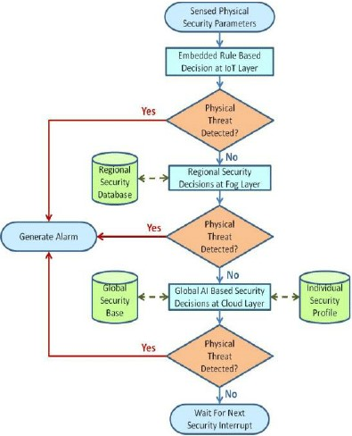
FIG.1

Step 1: System Initialization- Gather the necessary hardware components, including a GPS module, a microcontroller (e.g., Arduino), a GSM module for communication, and any sensors you want to integrate (e.g., for environmental monitoring).

Step 2: GPS Data Acquisition- Set up the GPS module to acquire location data. Periodically read GPS data (latitude and longitude).

Step 3: Data Processing and Analysis- Analyze the GPS data to identify the user's location. Apply filtering or smoothing techniques to improve location accuracy.

Step 4: Geofencing- Define geographical boundaries (geofences) for the user's safety. Compare the user's location with the geofence boundaries.

Step 5: User Safety Check - If the user is within the defined geofence boundaries, continue monitoring.

Step 6: User Outside Geofence - If the user exits the geofence, the system triggers an alert.

Step 7: Alert Generation and Communication - If an alert is triggered (user outside geofence), the system generates an alert. Use the GSM module to send alerts via SMS, calls, or data transmission.

Step 8: Emergency Contacts - Define a list of emergency contacts. Send alerts and location information to these contacts.

Step 9: Continuous Monitoring - Continuously monitor the user's location and safety status.

Step 10: Environmental Sensors - Integrate environmental sensors to monitor factors such as temperature, humidity, or air quality for additional safety features.

Step 11: Battery Management - Implement power-saving features to maximize device uptime, as continuous GPS usage can drain the battery quickly.

Step 12: User Interface (Optional) - Develop a user interface or mobile application for the user to configure settings and receive alerts.
Step 13: Testing and Calibration - Test the system under various scenarios to ensure accuracy and reliability. Calibrate the system for optimal performance.

Step 14: Deployment - Deploy the human security system for real-world use. Here's a simple flowchart representing the operation of the system:

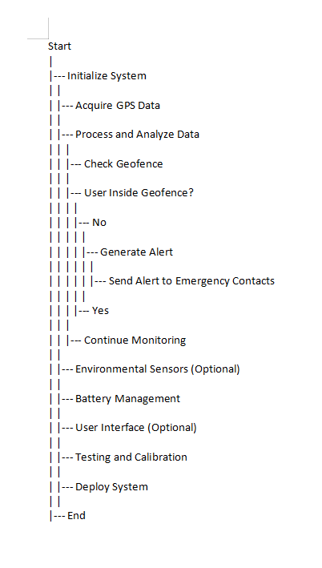
Fig.2

Chapter 4 Results analysis and validation

CODE:

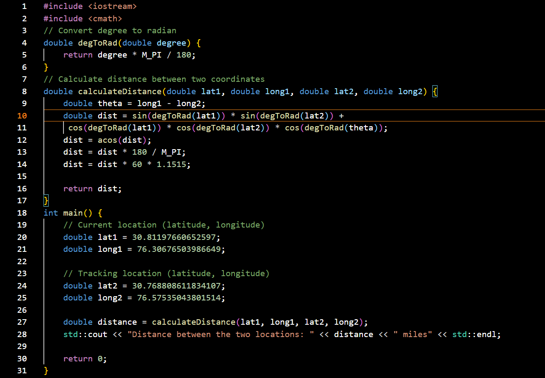

OUTPUT:
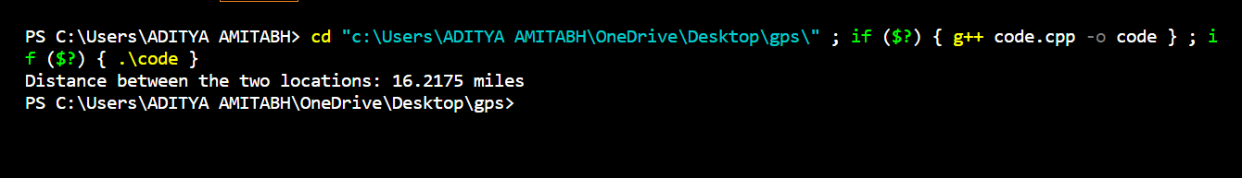

1. Requirements Analysis: This is the initial phase where you use project management tools like JIRA or Trello to document and keep track of project requirements. You create a requirements document that specifies the desired features and functionalities of the GPS-based human security system. This document serves as a blueprint for the project, outlining what the system needs to achieve.

2. System Design: In this phase, you use computer-aided design (CAD) software such as AutoCAD or SolidWorks to create detailed drawings and schematics of the system components. This includes developing 3D solid models to visualize the physical layout and placement of components, providing a visual representation of the system's design.

3.Component Selection and Procurement: To efficiently source the required components and materials, you utilize supply chain management software. This ensures that you can acquire the necessary hardware and equipment while managing costs and lead times effectively.

4. Hardware Integration: This step involves employing electronic design automation (EDA) tools like Altium Designer or KiCad, which are used to design custom printed circuit boards (PCBs) if needed. Circuit diagrams and schematics are developed using EDA tools for components like GPS modules, microcontrollers, sensors, and communication devices.

5. Firmware and Software Development: In this phase, integrated development environments (IDEs) such as Arduino IDE or Visual Studio are used to program microcontrollers and implement the system's logic. Additionally, you create a user interface or mobile application for configuration and alert management using software development tools.

6. Data Visualization: Data visualization tools like Tableau or Power BI are implemented to display real-time location data and environmental sensor readings. These tools help present the data collected by the system in a user-friendly and comprehensible format.

7. Testing and Characterization: A controlled testing environment is set up to validate the system's performance. GPS simulator tools are used to test the system's behavior under various GPS conditions. Data analysis and interpretation tools, like Python with data science libraries, are employed to process and make sense of the collected data.

8. Data Validation: To ensure the accuracy of the system, the GPS data produced by the system is compared with ground truth data. This validation step confirms that the GPS-based human security system is providing reliable and accurate location information.

9. Communication: Throughout the project, project management and communication tools like Slack or Microsoft Teams are used to facilitate team collaboration and provide updates on the project's progress. These tools also enable communication with stakeholders, including end-users and emergency contacts, through the system's communication features.

CHAPTER 5: CONCLUSION AND FUTURE SCOPE
The implementation of a human security system using GPS tracking technology is a comprehensive approach to enhancing personal safety and security. This system harnesses the capabilities of GPS technology, modern engineering tools, and data-driven insights to create a robust framework that empowers individuals to protect themselves. Here's a more detailed description of the key takeaways from this concept:

1. Improved Safety: GPS tracking provides real-time location data, allowing individuals to monitor their own safety, especially in potentially dangerous situations. By knowing their precise location, users can make informed decisions and take necessary actions to stay safe.

2.Efficient Design and Development: The system benefits from modern engineering tools such as Computer-Aided Design (CAD) for detailed schematics and layouts, Electronic Design Automation (EDA) for custom circuit design, and software development environments for creating applications. These tools streamline the design and development process, ensuring precision and efficiency.

3. Data-Driven Insights: The combination of GPS tracking and integrated environmental sensors collects valuable data about the user's surroundings. This data enables users to gain insights into their environment, which in turn supports informed decision-making, enhancing overall safety and security.

4. Communication and Alerting: The system's communication capabilities, which include SMS, calls, and data transmission, allow for immediate alerts to be sent to designated emergency contacts when the user's safety is compromised. This ensures a swift response in case of emergencies.

5. Testing and Validation: Rigorous testing, including the use of GPS simulation tools and data analysis, is essential to validate the system's accuracy and reliability. This step ensures that the system performs as intended and can be trusted in real-life situations.

6. User-Friendly Interfaces: User interfaces and mobile applications simplify system configuration and interaction. These interfaces are designed to be user-friendly, making the system accessible to a broader user base, regardless of their technical expertise.

7.Project Management and Reporting: Project management tools help track the progress of the system's development. Detailed reports provide documentation of the system's design, development, and testing, offering transparency and accountability throughout the project's lifecycle.

8. Deployment and Maintenance: Deploying the system in the target environment is a crucial step. Implementing remote monitoring and updates ensures ongoing functionality and adaptation to changing needs. This allows the system to evolve and remain effective over time.

9. Training and Education: Effective end-user training is essential to ensure that users can confidently use and manage the system. This empowers individuals to maximize the benefits of the system for their personal security, making them better prepared to handle potential threats.

5.1 Conclusion:
The use of GPS technology in human security systems has garnered significant interest in recent years, as revealed by a literature review. This review explores various potential applications of GPS technology in the realm of human security. Here's a description of the key findings and considerations from the review:

1. Potential Applications: The literature review identifies several promising applications of GPS technology in enhancing human security. These include:
- Location-Based Personal Task Reminder: GPS can be utilized to create a system that provides location-based reminders and alerts to mobile users, enhancing their safety and convenience.
- Psychological Research: GPS data analysis can support psychological research by offering insights into behavior and patterns related to personal security.
- Humanitarian Emergencies: GPS technology can be instrumental in monitoring and managing the movements of large populations during humanitarian emergencies, aiding in disaster response and relief efforts.

2. Challenges and Issues: The literature review also uncovers various challenges and issues that must be addressed when integrating GPS technology into human security systems. These include:
- Privacy Concerns: The collection and use of location data may raise privacy issues and concerns about how this information is handled and safeguarded.
- Ethical Considerations: Ethical dilemmas can arise from the use of GPS technology in human security, such as balancing the benefits of enhanced safety with potential invasions of privacy.
- Technological Advancements: Rapid advancements in GPS technology and related fields necessitate the development of flexible and adaptable systems that can keep pace with these changes.
- Emerging Location-Based Technologies: The emergence of new location-based technologies presents opportunities and challenges in the design and implementation of human security systems.

3. Project Goals and Objectives: The proposed goals and objectives of the project aim to address these challenges and create a human security system that is both responsive and adaptable to changing technological landscapes. By developing a human security system using GPS technology, the project seeks to ensure the safety of individuals while proactively addressing privacy, ethical, and technological concerns.

4. Insights and the Need for Further Research: The literature review provides valuable insights into the potential applications of GPS technology in human security systems. It underscores the importance of continued research and development in this area to harness the full potential of GPS technology for enhancing personal security while also managing the associated ethical and privacy considerations.

5.2 Future Scope:

Developing a Comprehensive Framework: Creating a comprehensive framework for a human security system using GPS location is a vital step. This framework should be designed to ensure the system's effectiveness, user-friendliness, and the resolution of privacy, ethical, and technological concerns. This is crucial as it sets the foundation for a holistic approach to personal security that respects individual rights and adapts to changing technology.

Studying Human Mobility Patterns: The potential applications of GPS technology in studying human mobility patterns are promising. Further research in this area can provide valuable insights into behavior and movement patterns, offering new opportunities to enhance human security. Understanding how individuals move can help in developing more targeted and effective safety measures.

Addressing Privacy and Ethical Concerns: As highlighted in the search results, privacy concerns and ethical considerations related to GPS technology use need to be addressed comprehensively. Future work can concentrate on developing strategies and policies to ensure that the system respects individual privacy rights and adheres to ethical standards, striking a balance between safety and personal liberties.

Scaling Up for a Wider Audience: The potential for GPS technology to ensure the safety of various vulnerable groups, such as children, the elderly, or women, is evident. Future work should focus on developing a plan for scaling up the system to reach a wider audience, making it accessible to those who need it most. Expanding the system's reach is crucial to maximizing its impact on human security.

Evaluating Long-Term Impact: The long-term impact of the system on human security needs to be evaluated to measure its effectiveness and identify opportunities for improvement. Continuous assessment can help refine the system, adapt it to changing needs, and ensure it remains a valuable tool for enhancing personal security over time.

REFERENCES

[1].https://playacademy.exceedlms.com/student/path/313809?referrer=interstitial&_gl=1*rn7vry*_gcl_aw*R0NMLjE2OTgxMzQ3OTguQ2p3S0NBancxdDJwQmhBRkVpd0FfLUEtTlBPTGF2cVZQaDRITFpRWnU1Z2pkdC11QmMtRnFoaGVoSmx6VG02WTJPU3ctZXZtT0RsclBSb0NoVmdRQXZEX0J3RQ..*_gcl_dc*R0NMLjE2OTgxMzQ3OTguQ2p3S0NBancxdDJwQmhBRkVpd0FfLUEtTlBPTGF2cVZQaDRITFpRWnU1Z2pkdC11QmMtRnFoaGVoSmx6VG02WTJPU3ctZXZtT0RsclBSb0NoVmdRQXZEX0J3RQ..*_gcl_au*MTkyNzg0MDE0MS4xNjk4MTM0Nzk4*_ga*MTc4OTQwNTA0Mi4xNjg4ODM4Njg0*_ga_76THV10NTW*MTY5ODE3NjMzNC44LjAuMTY5ODE3NjMzNC4wLjAuMA..&_ga=2.157416376.369937170.1698134798-1789405042.1688838684&_gac=1.180481493.1698134802.CjwKCAjw1t2pBhAFEiwA_-A-NPOLavqVPh4HLZQZu5gjdt-uBc-FqhhehJlzTm6Y2OSw-evmODlrPRoChVgQAvD_BwE

- Amazon Web Services. Authenticating Users of AWS Mobile Applications with a Token Vending Machine. AWS Identity and Access Management, July 2013. http://aws.amazon.com/articles/4611615499399490.

- R. Chirgwin. Amazon Is Decompiling Our Apps in Security Gaff Hunt, Says Dev. The Register, Mar. 2014. http://www.theregister.co.uk/2014/03/31/dev_lashes_ out_at_amazon_for_decompiling_his_app

[4].MixRank. http://www.mixrank.com
Y. Zhang, G. Huang, X. Liu, W. Zhang, H. Mei, and S. Yang. Refactoring Android Java Code for On-Demand Computation Offloading. In Proceedings of the 27th Annual ACM SIGPLAN Conference on Object-Oriented Programming, Systems, Languages, and Applications (OOPSLA 2012), Oct. 2012

